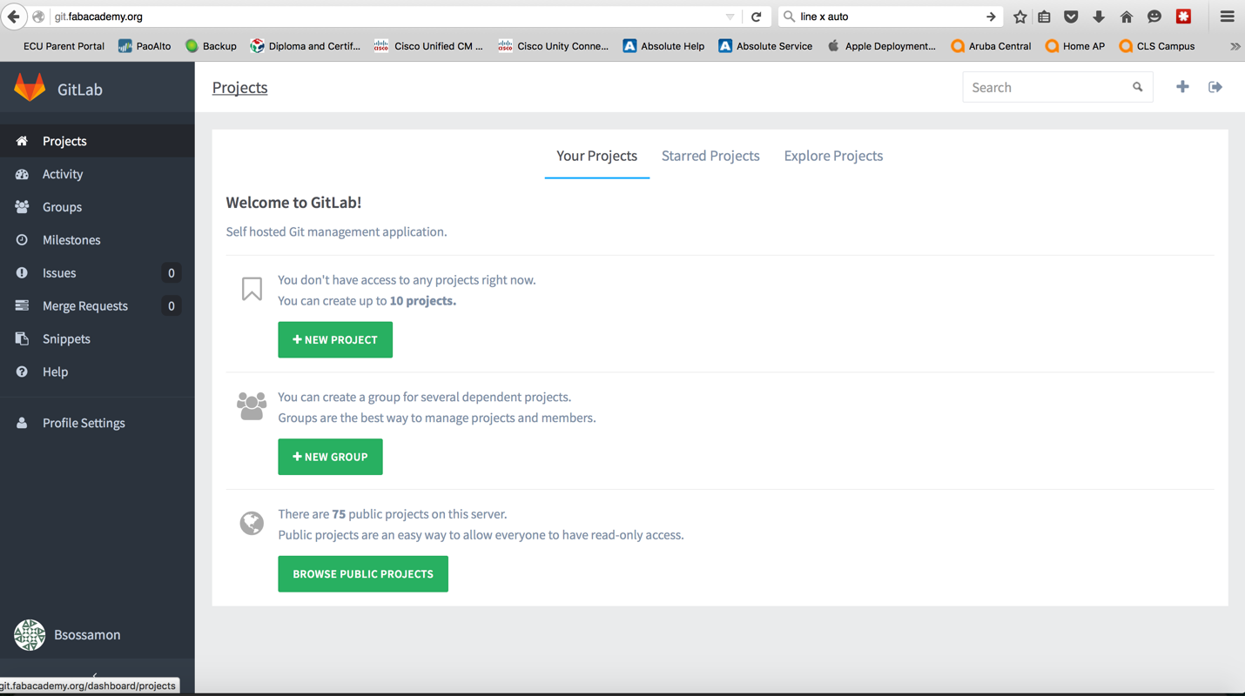

Login to it.fabacademy.org with the account you created for Fab Academy. Click on Profile Settings from the Left Side Bar.

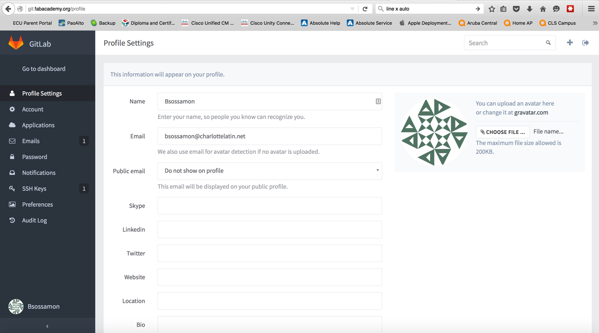

Click SSH Keys from the Left Side Bar.

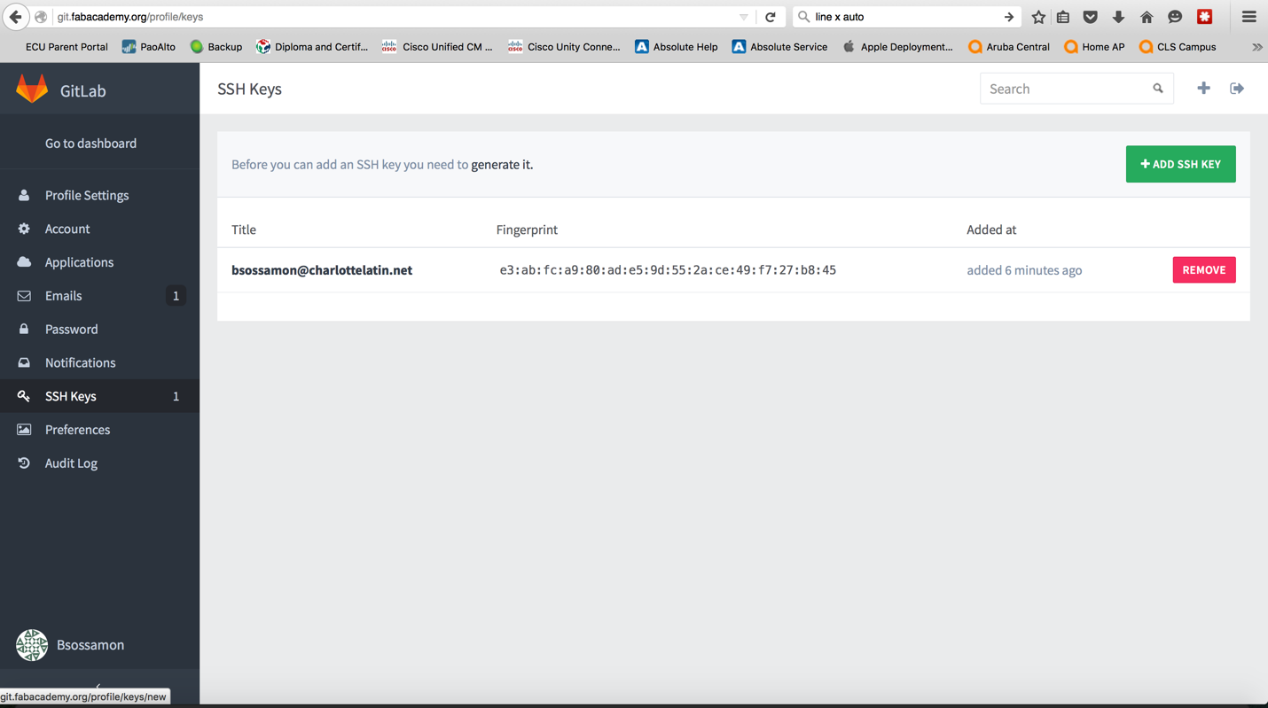

Click Add SSH Key on the top Right Green button. You will see the following screen. Bring up Terminal on Mac to start creating and coping the SSH Key

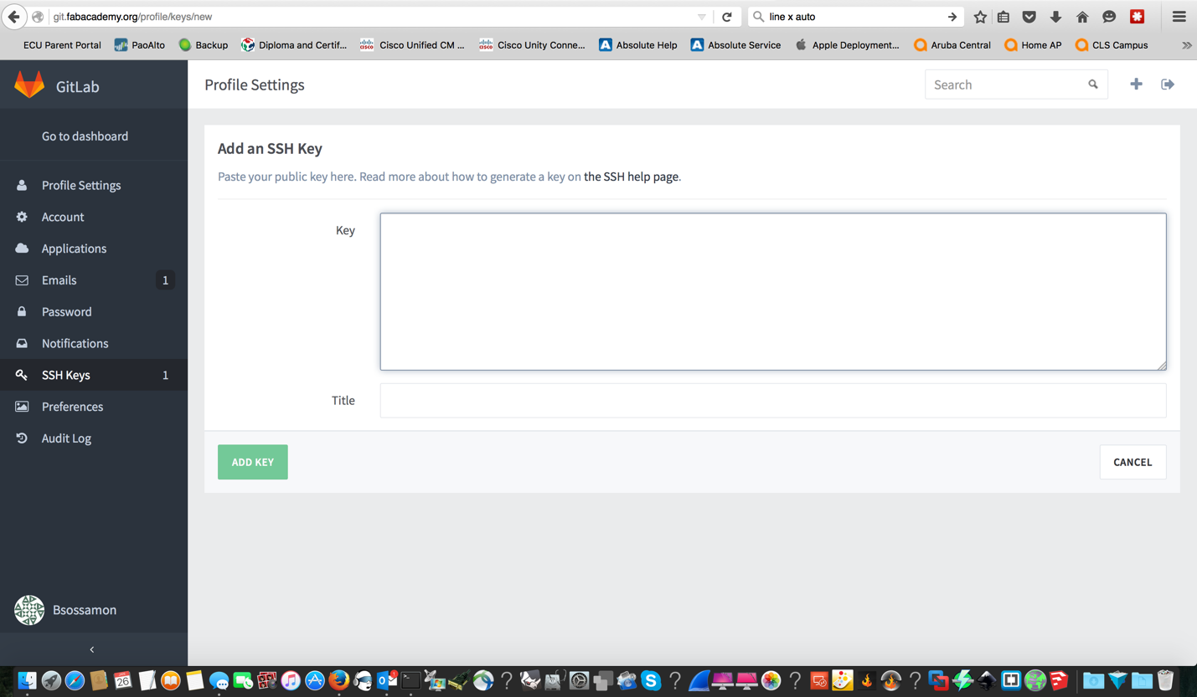

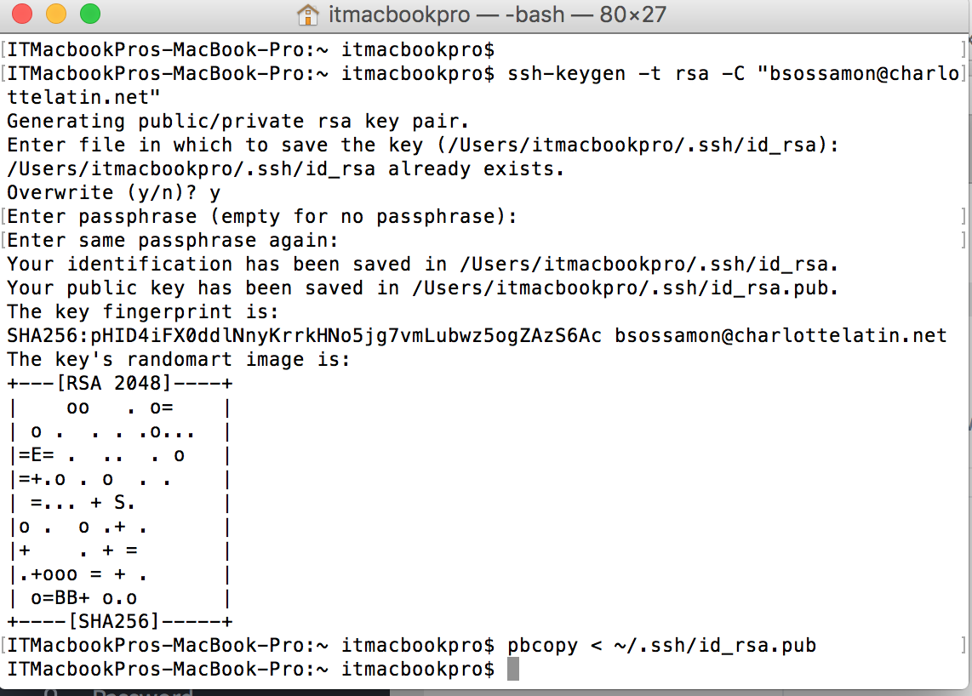

At terminal copy and paste the following command after replacing the email address to your email.

**ssh-keygen -t rsa -C "name@email.com"**

After you click enter 3 times to accept the defaults paste the following command to copy the SSH into your clip board.

**pbcopy < ~/.ssh/id_rsa.pub**

Go back to your Fab Academy web page like below and paste the copied SSH into the box. (Command/V) (CTRL V). Put your Email address as the title and save. You are now finished.

